States of a process are as following:

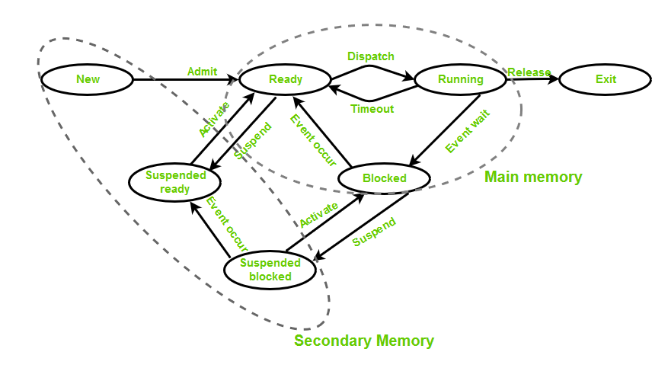

* **New (Create) –** In this step, the process is about to be created but not yet created, it is the program which is present in secondary memory that will be picked up by OS to create the process.
* **Ready –** New -> Ready to run. After the creation of a process, the process enters the ready state i.e. the process is loaded into the main memory. The process here is ready to run and is waiting to get the CPU time for its execution. Processes that are ready for execution by the CPU are maintained in a queue for ready processes.
* **Run –** The process is chosen by CPU for execution and the instructions within the process are executed by any one of the available CPU cores.
* **Blocked or wait –** Whenever the process requests access to I/O or needs input from the user or needs access to a critical region(the lock for which is already acquired) it enters the blocked or wait state. The process continues to wait in the main memory and does not require CPU. Once the I/O operation is completed the process goes to the ready state.
* **Terminated or completed –** Process is killed as well as PCB is deleted.
* **Suspend ready –** Process that was initially in the ready state but were swapped out of main memory(refer Virtual Memory topic) and placed onto external storage by scheduler are said to be in suspend ready state. The process will transition back to ready state whenever the process is again brought onto the main memory.
* **Suspend wait or suspend blocked –** Similar to suspend ready but uses the process which was performing I/O operation and lack of main memory caused them to move to secondary memory.  
  When work is finished it may go to suspend ready.

**CPU and IO Bound Processes:**  
If the process is intensive in terms of CPU operations then it is called CPU bound process. Similarly, If the process is intensive in terms of I/O operations then it is called IO bound process.

**Types of schedulers:**

1. **Long term – performance –** Makes a decision about how many processes should be made to stay in the ready state, this decides the degree of multiprogramming. Once a decision is taken it lasts for a long time hence called long term scheduler.
2. **Short term – Context switching time –** Short term scheduler will decide which process to be executed next and then it will call dispatcher. A dispatcher is a software that moves process from ready to run and vice versa. In other words, it is context switching.
3. **Medium term – Swapping time –** Suspension decision is taken by medium term scheduler. Medium term scheduler is used for swapping that is moving the process from main memory to secondary and vice versa.

**Multiprogramming –** We have many processes ready to run. There are two types of multiprogramming:

1. **Pre-emption –** Process is forcefully removed from CPU. Pre-emption is also called as time sharing or multitasking.
2. **Non pre-emption –** Processes are not removed until they complete the execution.

**Degree of multiprogramming –**  
The number of processes that can reside in the ready state at maximum decides the degree of multiprogramming, e.g., if the degree of programming = 100, this means 100 processes can reside in the ready state at maximum.